Without reduce: Correctly displays the numerator.

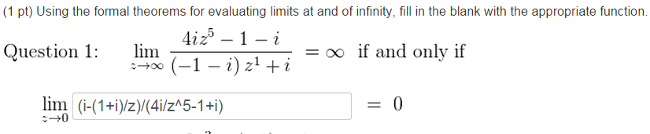

With reduce: Prettier, but incorrectly displays the numerator.

